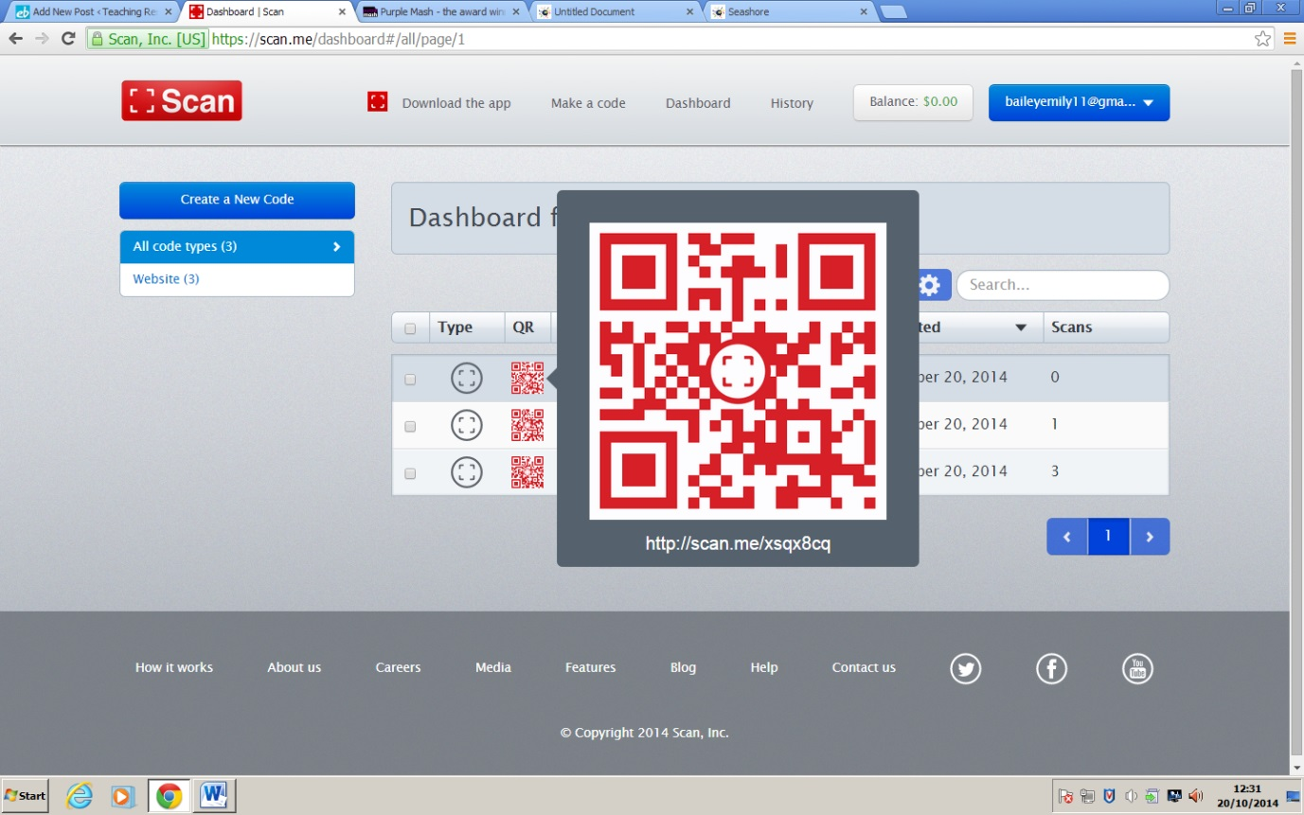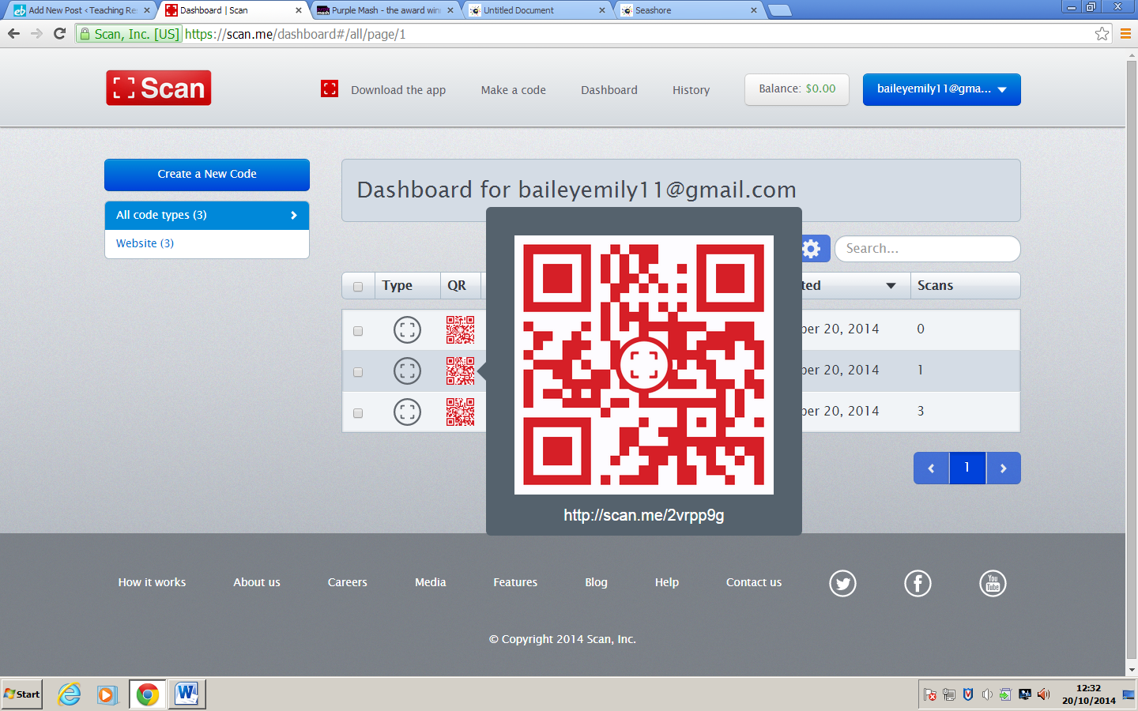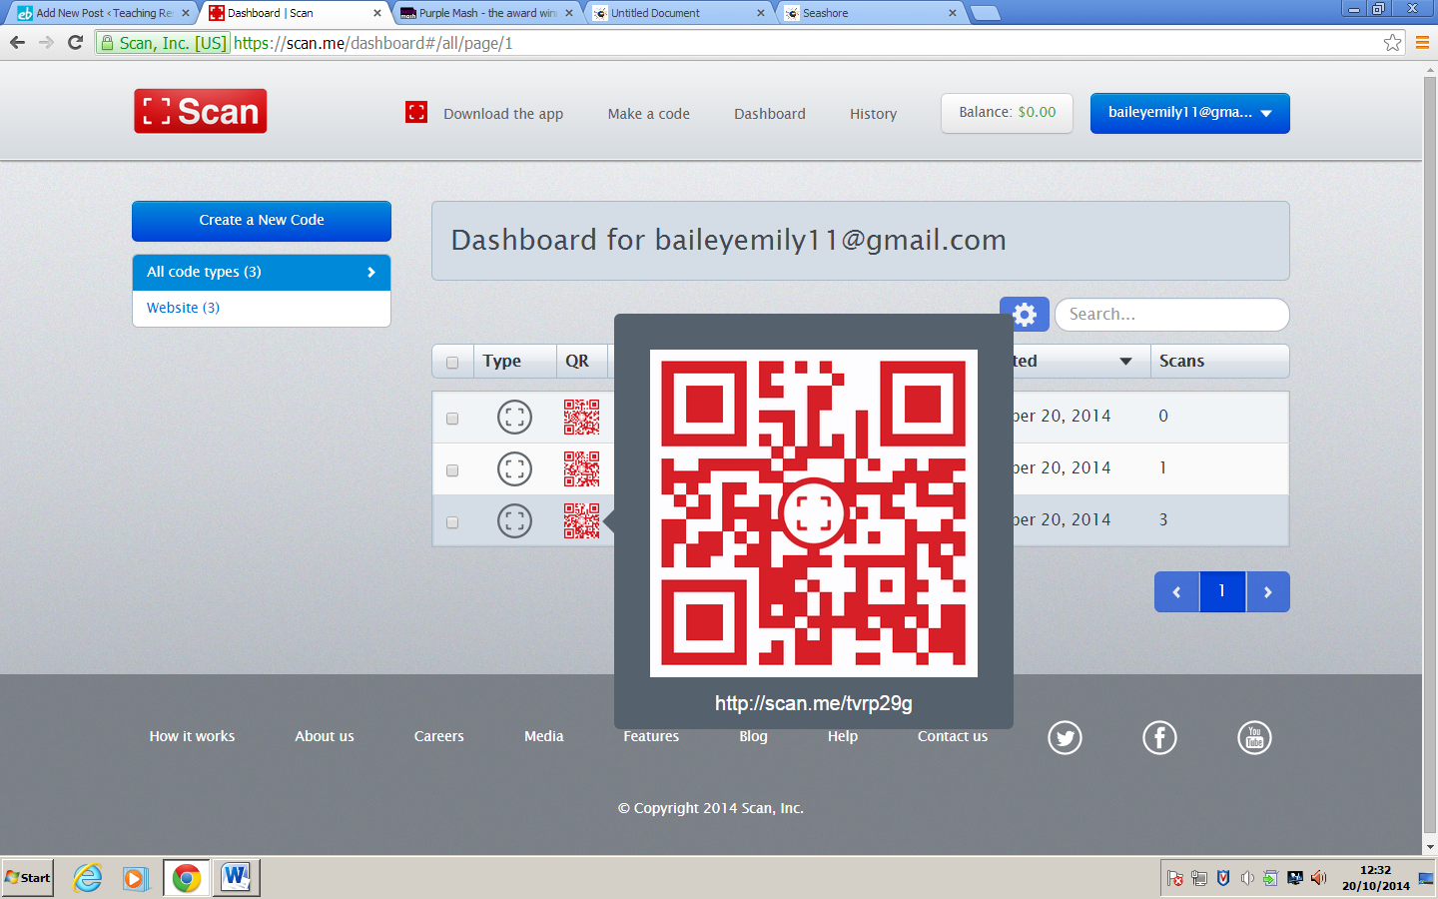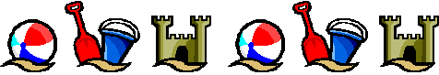

**Holiday Brochure**

This activity is also on Purple Mash, children can create their own brochure for a certain seaside. They can put key facts on it and do their own research. You can link this easily with Literacy, for example asking them to use at least 5 adjectives.

**Deep Sea Diver**

This is another activity on Purple Mash where children can take a picture a picture of themselves within the body of a diver; they can add text or record themselves speaking as this person. This would be good at the end of a topic to sum up what the child has learnt about the seaside and the sea.

**Beach Huts**

This code will take you to an activity on Purple Mash where you can colour in and design your own beach huts. This could be used a plan to building beach huts in a D&T lesson or to add to a display of the seaside. There are many uses for it.

**The Seaside!**