Pirates
We chose the pirates theme because it was something we all wanted to do. This was an interesting topic with lots of work we could adapt to use with children.
We used Key Stage 1 as a basis for this and began to develop ideas around this, finding some useful child friendly sites that they can access and creating a pirate story that can be read to children.
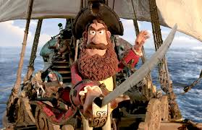
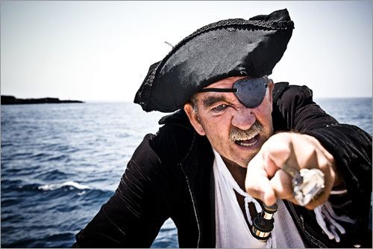

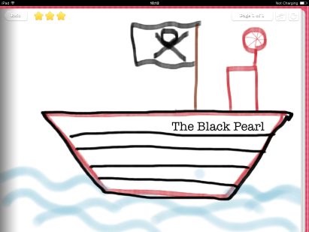
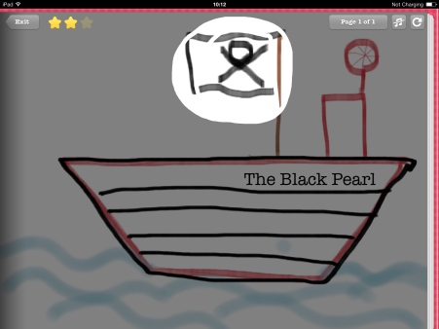

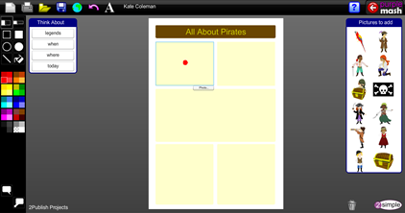

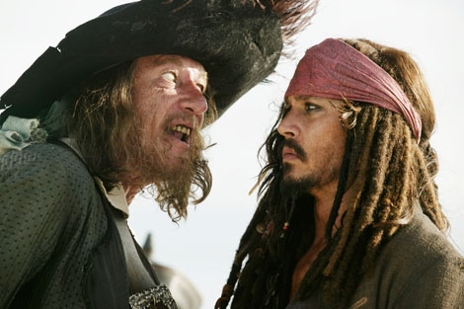
Pirates

Pirate Ship website – Useful website for looking at a pirate ship and the different functions of a pirate ship.
Pirate Activities website – Various activities that can be done with children, giving you an idea of what you could do.
Famous Pirates- Website that has various famous pirates on it that is present in a child friendly manner.
Video- Pirate Song Video- Song about pirates that can be used with children to begin a lesson.
Video-A Pirate Story by Eric Herman- Pirate story narrated that engages children.
Video-Neverland Pirates - recognisable to children.

Pirate Profiles - Design your own pirate name and pirate.

Design a map - Gets children to design their own map which they could follow.

Design a flag- Children design their own flag design.
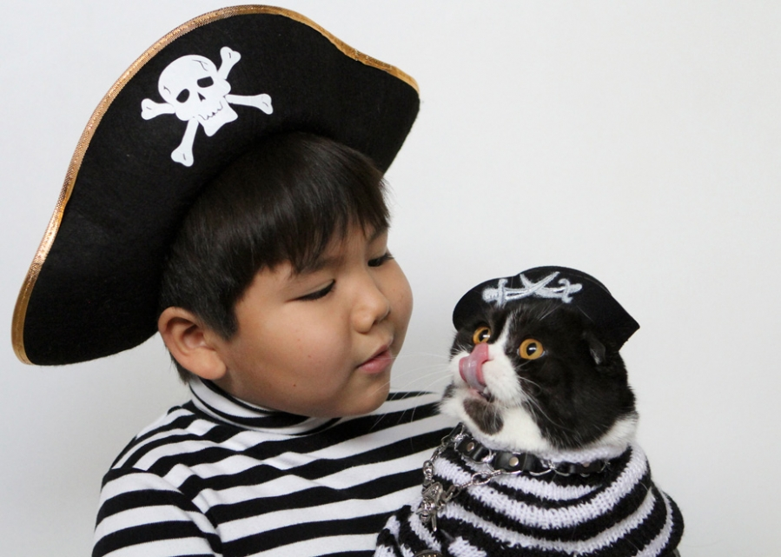
http://www.storyjumper.com/book/index/11962662/Captain-Red-Beard
This book could be used with children to allow them to see a pirate story on the interactive whiteboard. The story is a typical pirate story with kid friendly language. The story does not have an ending as it allows children to come and make their own ending, they could do this through role play or story.

