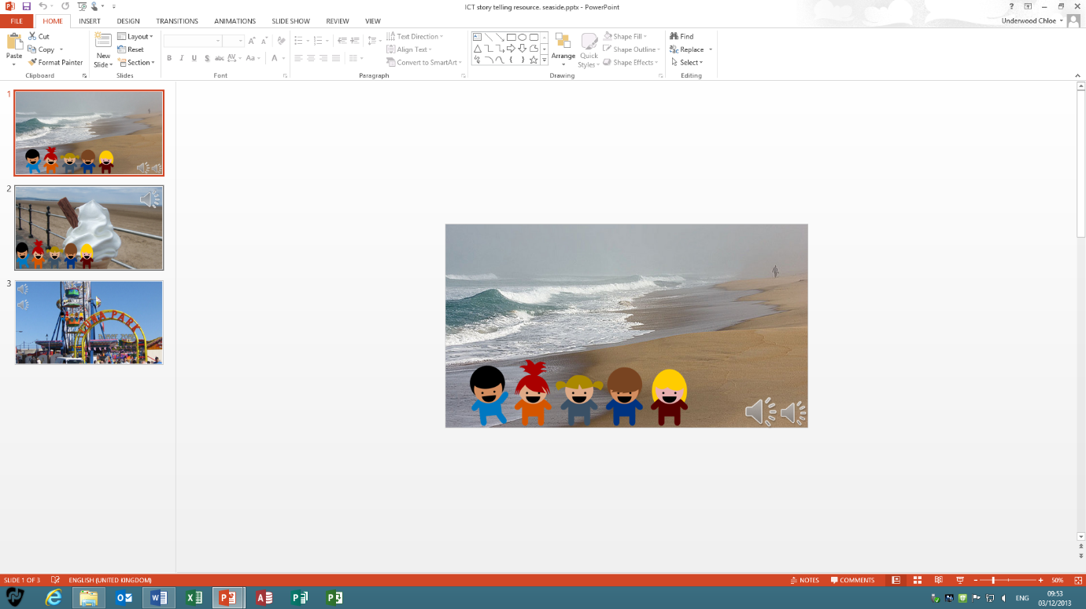

**Presentation Tools for Story Telling**

**By Chloe Underwood and Collette Norman**

**Focus:**

To make a digital story telling resource using PowerPoint

**Suitable For:**

Key Stage One. Children will need previous experience of using PowerPoint and will need to be able to taught have to use PowerPoint.

**What you need:**

-Microsoft PowerPoint

-Access to pictures (This could be through the internet but the children would need adult supervision and knowledge of online safety)

-Headphone to listen to sounds

**What you do:**

Children are able to add pictures to presentation slides and add sounds to create a story board. Children can alter the size of pictures and use headphones to add suitable sounds. Our example involves a set of images around a seaside theme with noises that you would hear at the seaside.

**Learning Benefits:**

Children can listen to and identify sounds which links to phonics. Children are able listen to music and match the tone to the image, develop awareness of different environments, recognise different environments and create a story about an environment.

**Taking it further:**

You could extend this further by asking children to type sentences and introduce characters and objects to add to their story telling.