Treasure hunt around park campus, University of Northampton

Focus
For children to use QR codes successfully in order to complete the treasure hunt. To learn about the new environment that they are in.

Suitable
Any children or adults who are getting to know a new environment.

What you need
Print the pages below and place them in the recommended areas. Each group will need an ipad/ ipod touch with the app ‘scan’.

What you do
Children will be given a task and will have to use the QR codes and devices to get to the final point and receive the prize. Start by giving children the first code and letting them follow the clues. Have a prize ready for children for when they finish the treasure hunt.

Learning Benefits
Becoming more familiar with ICT devices
Following directions
Can be linked to other areas of the curriculum/topics
Can be used for instructions eg. Within a science or DT activity, scan the code to find out what to do next.

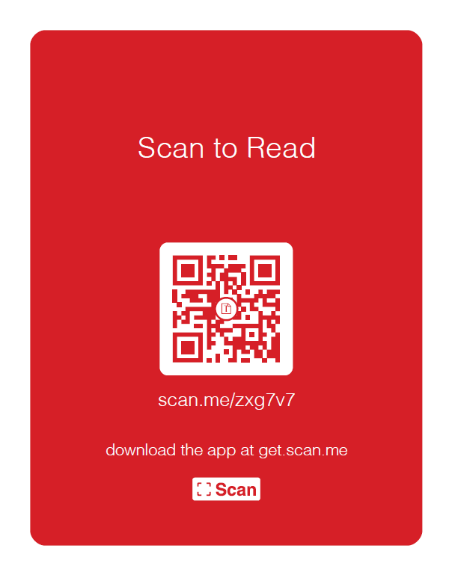
- Give to children to start treasure hunt.

- At the restaurant
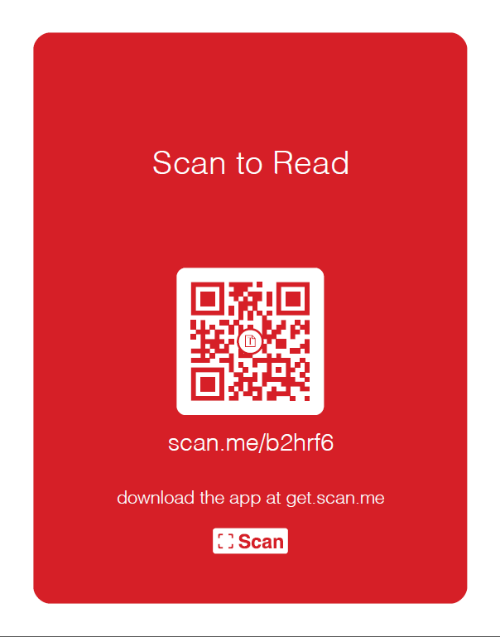

- At forest school
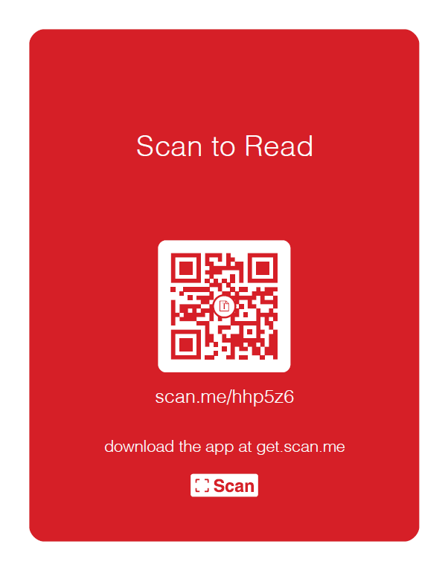

- At the library
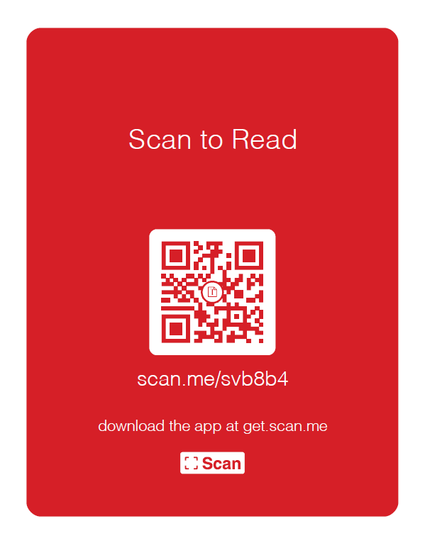

- Dance studio
