**C:\Users\pete\AppData\Local\Microsoft\Windows\Temporary Internet Files\Content.IE5\X6WFL160\MC900019670[1].wmfC:\Users\pete\AppData\Local\Microsoft\Windows\Temporary Internet Files\Content.IE5\X6WFL160\MC900019670[1].wmfThe Autumn Season – Our Encyclopaedia**

**Created by Rachael Aris, Tracey Box, Kat De-Lara and Ellen Abbott**

**Web Resources**

Autumn Trees Video - <http://www.bbc.co.uk/learningzone/clips/9453.html>

This is a short clip from the Cbeebies website that shows children exploring the outdoor environment in the autumn season.

Activity Village - <http://www.activityvillage.co.uk/autumn>

The activity village website provides a wide range of activities for children of all ages to engage in. Within the autumn season resources colouring pages, games and craft activity ideas can be found.

**Stories**

Autumn - <http://www.amazon.co.uk/Autumn-Gerda-Muller/dp/0863151914/ref=sr_1_1?ie=UTF8&qid=1382608194&sr=8-1&keywords=autumn>

This is part of a series of books with no text looking at the seasons of the year. The pictures in this book will allow the children to create their own stories about the autumn season.

The Very Helpful Hedgehog - <http://www.amazon.co.uk/Very-Helpful-Hedgehog-Rosie-Wellesley/dp/184365198X/ref=sr_1_5?ie=UTF8&qid=1382802054&sr=8-5&keywords=autumn+stories+for+children>

This story is set in the autumn season; an apple falls from a tree and gets stuck to a hedgehog. The story is based around friendship and being helpful but the children can also explore the pictures and consider what happens in the autumn season; e.g. leaves and fruit falling from the trees.

C:\Users\pete\AppData\Local\Microsoft\Windows\Temporary Internet Files\Content.IE5\X6WFL160\MC900019670[1].wmfC:\Users\pete\AppData\Local\Microsoft\Windows\Temporary Internet Files\Content.IE5\X6WFL160\MC900019670[1].wmf

C:\Users\pete\AppData\Local\Microsoft\Windows\Temporary Internet Files\Content.IE5\X6WFL160\MC900019670[1].wmfC:\Users\pete\AppData\Local\Microsoft\Windows\Temporary Internet Files\Content.IE5\X6WFL160\MC900019670[1].wmf

**Activities**

Pic collage – Looked at by Rachael

We used pic collage to create a poster of autumn photos from the internet. This poster could be used to introduce the topic of autumn to the children. They can consider things such as the colours of autumn and the weather.

Further into the topic the children could go on an Autumn Walk around their local area taking photos of what they see on the iPads. In the classroom the children can then use the photos they have taken to create their own pic collage or comic strip using Strip Design.

Subject areas included within this are ICT, Science and Geography.

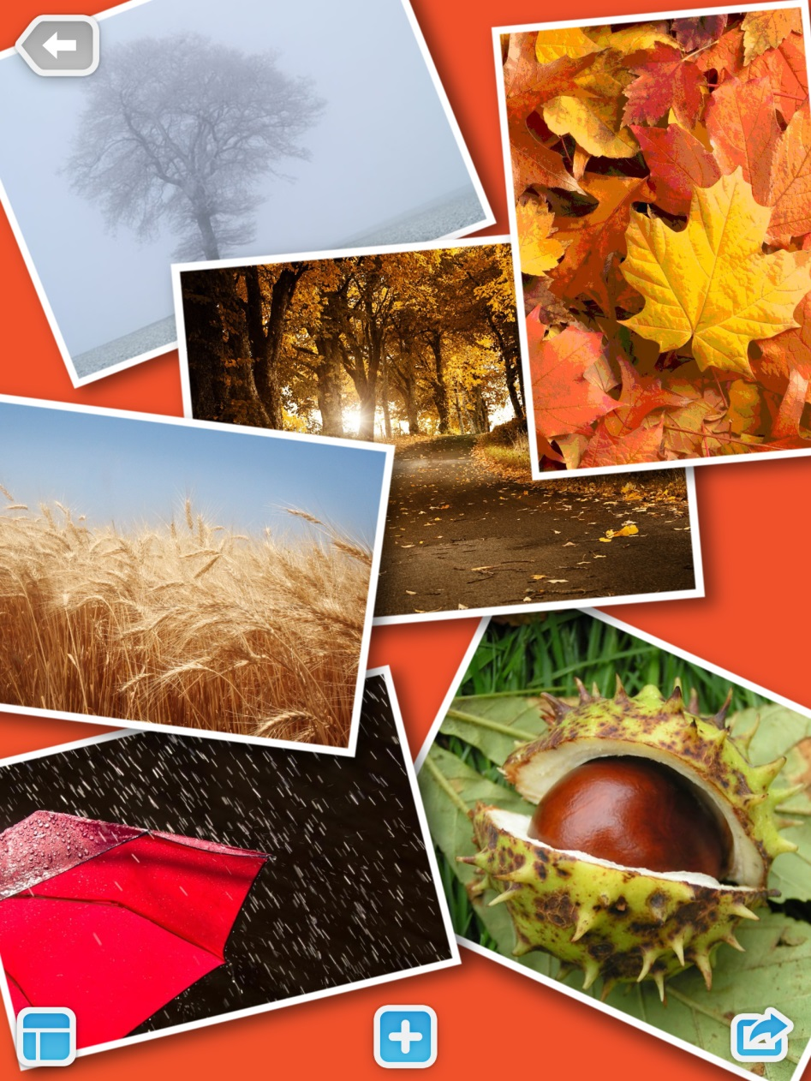

C:\Users\pete\AppData\Local\Microsoft\Windows\Temporary Internet Files\Content.IE5\X6WFL160\MC900019670[1].wmfC:\Users\pete\AppData\Local\Microsoft\Windows\Temporary Internet Files\Content.IE5\X6WFL160\MC900019670[1].wmf

C:\Users\pete\AppData\Local\Microsoft\Windows\Temporary Internet Files\Content.IE5\X6WFL160\MC900019670[1].wmfC:\Users\pete\AppData\Local\Microsoft\Windows\Temporary Internet Files\Content.IE5\X6WFL160\MC900019670[1].wmf

Phoster – Looked at by Rachael

To incorporate a maths and literacy element we thought about the children looking at autumn colours, learning how to read them and some children may be able to write them. We created a poster on the Phoster app on the iPad that could be shown to the children as an example of something they could create.

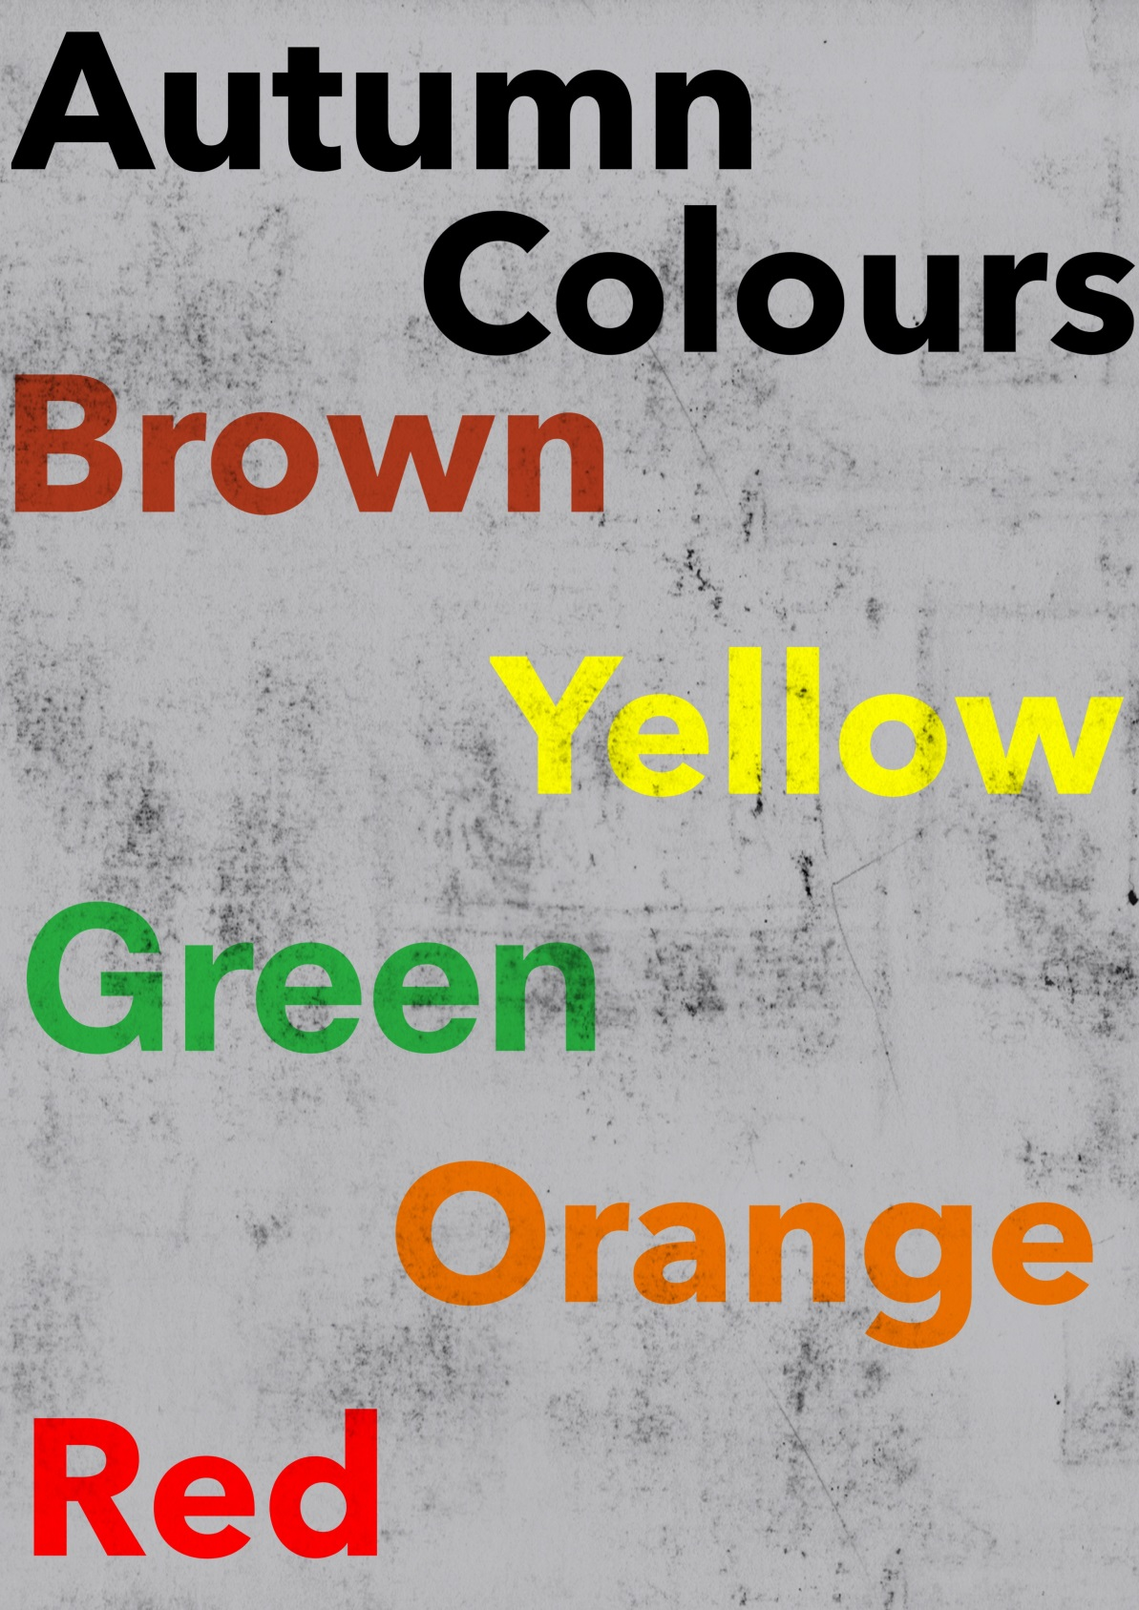

C:\Users\pete\AppData\Local\Microsoft\Windows\Temporary Internet Files\Content.IE5\X6WFL160\MC900019670[1].wmfC:\Users\pete\AppData\Local\Microsoft\Windows\Temporary Internet Files\Content.IE5\X6WFL160\MC900019670[1].wmf

C:\Users\pete\AppData\Local\Microsoft\Windows\Temporary Internet Files\Content.IE5\X6WFL160\MC900019670[1].wmfC:\Users\pete\AppData\Local\Microsoft\Windows\Temporary Internet Files\Content.IE5\X6WFL160\MC900019670[1].wmf

Brushes – Looked at by Kat and Ellen

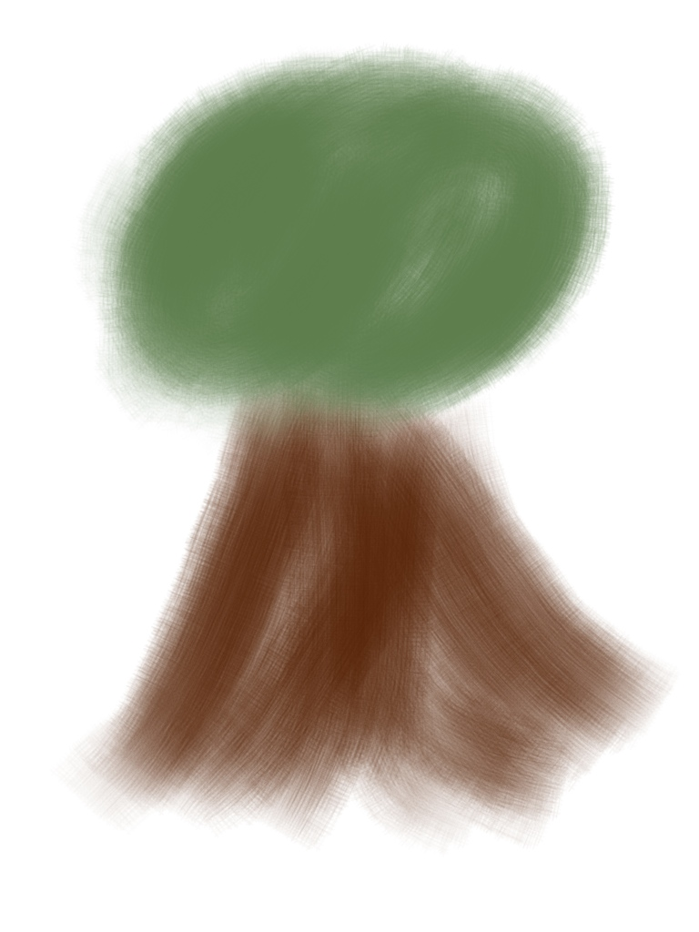An Art and ICT element can be added to the topic through the iPad app Brushes. This app allows you to draw a picture using the variety of brushes, the app then plays back the drawing you have created. We discussed the use of the app and decided that it could used to support the children in consolidating their learning about the autumn season. They could draw the things they have seen on the Autumn Walk using the app alongside various other art and craft activities that could be planned for; such as leave print and bark rubbing.

Brushes Video - <http://www.youtube.com/watch?v=7WJL1x-puKo&feature=youtu.be>

C:\Users\pete\AppData\Local\Microsoft\Windows\Temporary Internet Files\Content.IE5\X6WFL160\MC900019670[1].wmfC:\Users\pete\AppData\Local\Microsoft\Windows\Temporary Internet Files\Content.IE5\X6WFL160\MC900019670[1].wmf

C:\Users\pete\AppData\Local\Microsoft\Windows\Temporary Internet Files\Content.IE5\X6WFL160\MC900019670[1].wmfC:\Users\pete\AppData\Local\Microsoft\Windows\Temporary Internet Files\Content.IE5\X6WFL160\MC900019670[1].wmf

Purple Mash – Looked at by Tracey

We found the Purple Mash website to be a great asset in supporting us to create resources for our theme; the website had a section on autumn that can be found at - <http://www.purplemash.co.uk/#/home/autumn>.

We used the website to create autumn poems and sentences and conker posters for literacy based activities. The site was easy to navigate and is something that some of the children would be able to do independently or in small groups. We found that what had been created could be printed off; we discussed that these could be displayed in the classroom to show children’s work or to act as a stimulus for writing activities.

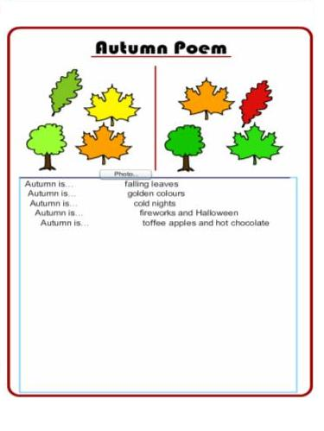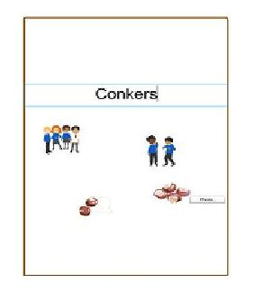An aspect of autumn the children will know is bonfire night. Considering this we also used the website to create a fireworks picture. This is definitely something the children could engage with independently or with a few friends. A discussion about the colours used could take place for a numeracy element as well as asking the children to consider how they could keep themselves safe when watching fireworks.

C:\Users\pete\AppData\Local\Microsoft\Windows\Temporary Internet Files\Content.IE5\X6WFL160\MC900019670[1].wmfC:\Users\pete\AppData\Local\Microsoft\Windows\Temporary Internet Files\Content.IE5\X6WFL160\MC900019670[1].wmf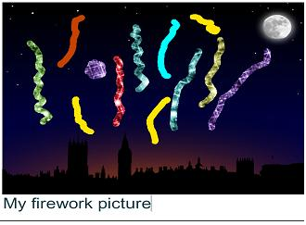

Pictures from Tracey’s blog for

session 4.