Assessment Guidance

Assessment Support
Specific support sessions for this assessment will be provided by the module team and notified through NILE. You can also access individual support and guidance for your assessments from Library and Learning Services. You can access a range of different service to support you with the skills you need to complete your assessment. https://www.northampton.ac.uk/student-life/support/academic-support/
You may also visit the Skills Hub to discover the online support resources to support your assessments and academic skills.

Use of Generative AI within assessments at UON

AI for students: 10 things you need to know

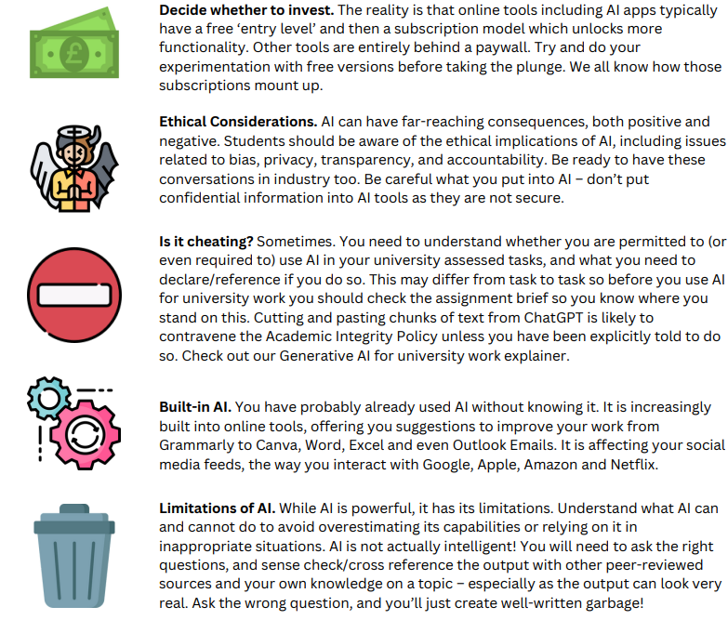
Please access the following webpage for further information on the University of Northampton’s position on the use of AI within academic work.

Generative AI and university work
Some uses of Generative AI may deemed as unethical in your assessment. Please read the following infographic to understand the difference between ethical and unethical use of Generative AI.

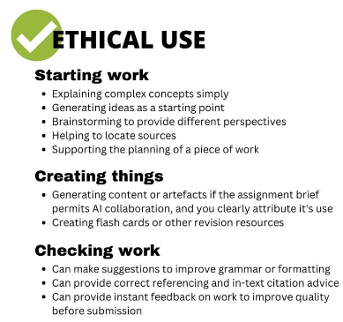
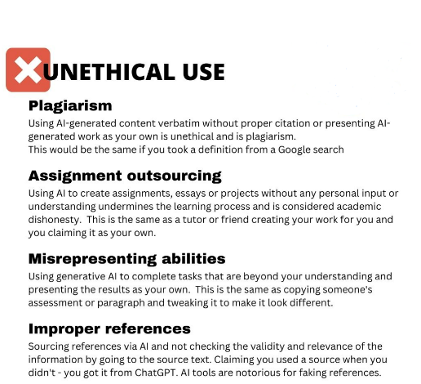

Further guidance on the allowable use of Generative AI will be clarified by the module team.

These may range between:

Absolutely no use of Generative AI allowed
Generative AI allowed in support of preparation of work
Sections of work submitted may include properly referenced and acknowledged AI generated contributions
Generative AI is core to the completion of the assessment, which cannot be completed unless Generative AI is used.

Please access the following position guidance from University of Northampton on the use of Generative AI within assessments.

Please also see these resources to support you in referencing the use of AI within your work:

Use of AI Tools in Academic Work - Citing and Referencing Guidance
https://libguides.northampton.ac.uk/referencing/ai

Academic Integrity and Misconduct
Unless this is a group assessment, the work you produce must be your own, with work taken from any other source properly referenced and attributed. This means that it is an infringement of academic integrity and, therefore, academic misconduct to ask someone else to carry out all or some of the work for you, whether paid or unpaid, or to use the work of another student whether current or previously submitted.

For further guidance on what constitutes plagiarism, contract cheating or collusion, inappropriate use of Generative AI, or any other infringement of academic integrity, please read the University’s Academic Integrity and Misconduct Policy. Other useful resources to help with understanding academic integrity are available from UNPAC - the University of Northampton’s Plagiarism Avoidance Course.

N.B. The penalties for academic misconduct are severe and include failing the assessment, failing the module and even expulsion from the university.

Assessment Submission
To submit your work electronically, please go to the ‘Assessment and submission’ area on the NILE site and use the relevant submission point to upload the assignment deliverable. The deadline for this is 11.59pm (UK local time) on the date of submission. Please note that Essays and text-based reports should be submitted as Microsoft Word documents (.doc or .docx), or as guided within the assignment.

Written work submitted to Turnitin will be subject to anti-plagiarism detection software. Turnitin checks student work for possible textual matches against internet available resources and its own proprietary database.

When you upload your work correctly to Turnitin you will receive a receipt which is your record and proof of submission. If your assessment is not submitted to Turnitin, rather than a receipt, you will see a green banner at the top of the screen that denotes successful submission.

N.B Work emailed directly to your tutor will not be marked.

Late submission of work
For first assignment submission window (first sit), if an item of assessment is submitted late and an extension has not been granted, the following will apply:

- Within one week of the original deadline – work will be marked and returned with full feedback and awarded a maximum bare pass grade.
- More than one week from original deadline – grade achievable LG (L indicating late).

For resits there are no allowances for work submitted late and it will be treated as a non-submission.

Please see the Assessment and Feedback Policy for full information on the processes related to assessment, grading and feedback, including anonymous marking/grading. DO NOT add your name to you submitted work, ONLY include your student number, unless otherwise advised.

You will also find Guidance on grades and resit opportunities from the main University website. Also explained there are the meanings of the various G grades at the bottom of the grading scale including LG mentioned above.

Extensions
The University of Northampton’s general policy about extensions is to be supportive of students who have genuine difficulties in meeting an assessment deadline. It is not intended for use where pressures of work could have reasonably been anticipated.

For full details please refer to the Extensions Policy. Extensions are only available for first sits – they are not available for resits.

Mitigating Circumstances
For full guidance on Mitigating circumstances please go to Mitigating Circumstances where you will find information on the policy as well as guidance and the form for making an application. Please also see Extensions & Mitigating Circumstances guide 22_23 that compares your options.

Please note, however, that an application to defer an assessment on the grounds of mitigating circumstances should normally be made in advance of the submission deadline or examination date.

Feedback and Grades
Feedback on your work and the Grade can be accessed through clicking on the “Gradebook” on Module’s NILE site. Feedback comments will be provided in TurnItIn where appropriate, which you can access via the Gradebook link on the NILE site, and clicking on your submitted work. You can also access it from the link used to originally submit the work in the submission point within Assessments and submission

Marking Rubric template

Learning Outcomes addressed through this assignment… | No submission / no evidence Work submitted is of no academic value / nothing submitted. | Fail  Evidence included or provided but missing some very important aspects. | Pass  Of satisfactory quality, demonstrating evidence of achieving the requirements of the learning outcomes. | Commended  Of sound quality, demonstrating evidence which is sufficient and appropriate to the task or activity. | Merit  Of high quality, demonstrating evidence which is rigorous and convincing, appropriate to the task or activity. | Distinction  Of very high quality, demonstrating evidence which is strong, robust and consistent, appropriate to the task or activity.
LO A | No attempt to address the learning outcome
LO C | No attempt to address the learning outcome
Academic / Professional quality | Unsatisfactory command of academic / professional conventions appropriate to the discipline. | Poor command of academic / professional conventions appropriate to the discipline. | Satisfactory command of academic / professional conventions appropriate to the discipline. | Sound command of academic / professional conventions sufficient and appropriate to the discipline. | Rigorous command of academic / professional conventions appropriate to the discipline. | Authoritative  command of academic / professional conventions appropriate to the discipline.

