How to add an idea to our Resource Bank

- If you would like to contribute a resource please contact helen.caldwell@northampton.ac.uk for a login. Or if you are already using MyPad in Nile you can apply to join using My Class on your blog Dashboard using the directions below.

- Go to My Sites on your blog dashboard and choose a blog that you are not using or create a new site (this is because you can only join one class blog with each of your blogs).

- On the dashboard of this blog select My Class and Join A Class.
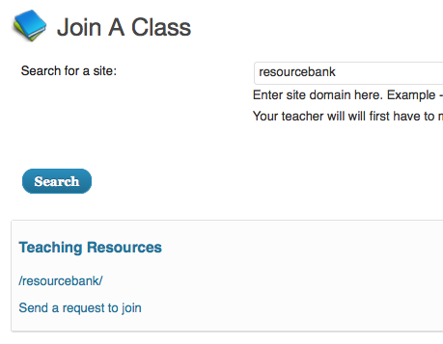

Search for resourcebank and then choose Send a request to join.

- Once your request has been approved you will be able to login to http://mypad.northampton.ac.uk/resourcebank .

- Go to the Dashboard and Posts and Add New Post.

- To ensure your resource displays neatly give it short a title of up to 6 words and begin your post with a description of around 10 words.

- Make sure you include an image. If it is someone else’s image check the copyright and provide a link to where it came from.

- Resources might take many forms: a lesson plan, a set of links, a unit of work, a media resource to introduce a topic, or a template to help children visualise an end product. They could be as simple as 'My three top tips for...' , a worksheet or a set of slides (see http://www.tes.co.uk/teaching-resources/ for ideas).

- Here are some suggested headings but feel free to use whatever best fits your resource: Subject, Key Stage, Title, Idea, Key Questions, Skills, Activities, Taking it Further, Useful Links, Contributor.

- Acknowledge yourself as the contributor at the end of the post and provide a link to your own blog if you want to.

- Finally please add a category (subject area) and tags (key words) to make it easy to find your resource.
All contributions and comments are immensely welcome. Thank you for joining in!

