To add tags and categories to your blog:
Tags and categories make your blog easier to navigate.
When you are posting in the Dashboard you have the option to add categories and tags:
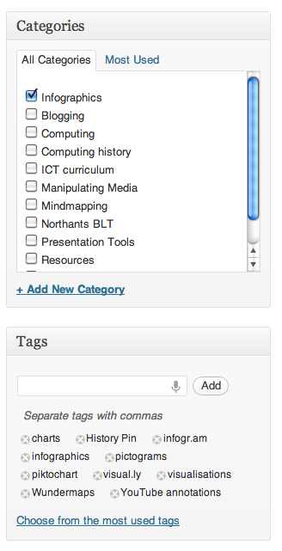
You add one Category for each post and several tags. Tags are keywords to describe the content. Separate them with commas.
Once you’ve made tags you can go to Appearance and Widgets and drag the Tag Cloud and Categories across to the Sidebar so that they are displayed on your blog.

