To customise the sidebar of your blog

You can change the display in your blog sidebars by activating Plugins and then reordering how they display in Widgets. First go to the Dashboard.

- In Appearance and Theme Options you may have the option to change the arrangement of columns.
- In Plugins you can activate the extras you would like to use. I go for AddThis Social Share, Akismet, Widget Pack and WP-Cumulus. Just click on Activate. More about the Widget Pack here. Find more advanced widget options on www.widgetbox.com or Edublogs Help.
- Go back to Appearance and Widgets. Drag widgets from Available Widgets into Main Sidebar. Drag to reorder within the sidebar.
- To add widgets from widgetbox.com or elsewhere that involve an embed code, you need to paste the code into a Text Widget:
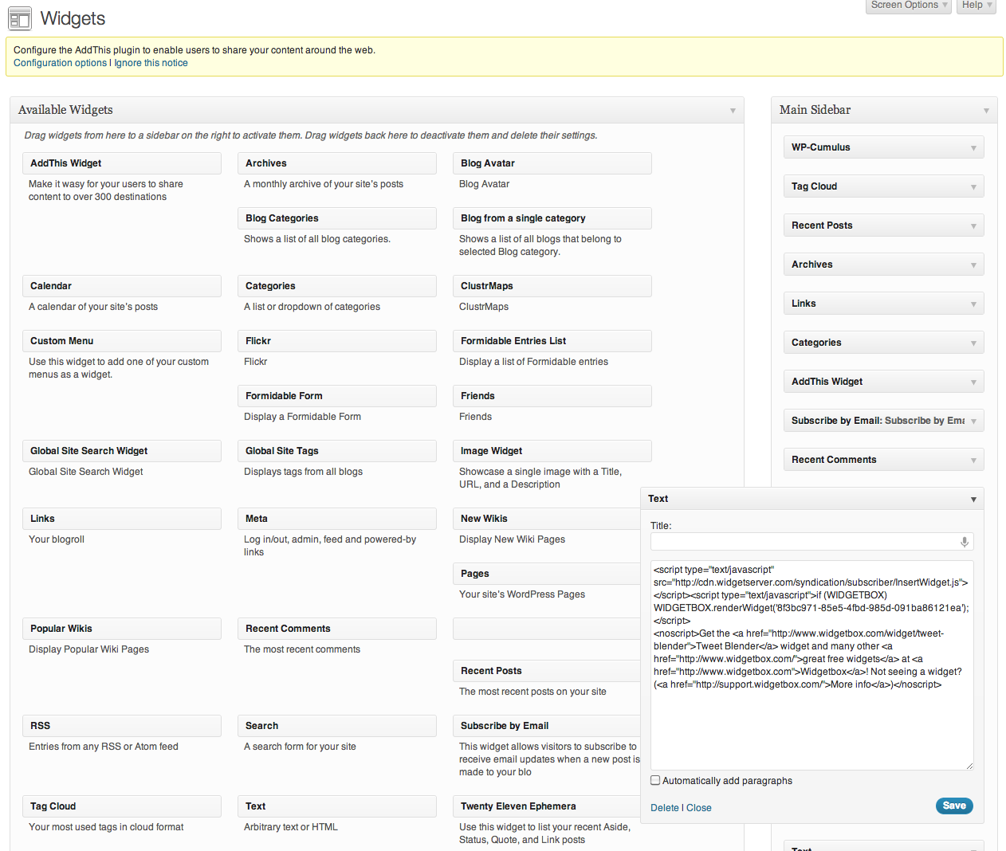

- My favourite sidebar line up includes WP-Cumulus for animated tags, Tag Cloud, Recent Posts, Archives, Links, Categories, AddThisWidget, Subscribe by Email, Recent Comments and also Clustrmaps and Twitter embedded as Text Widgets.
- Make sure each of your blogposts has Tags and a Category.
- Make sure your links are marked Blogroll.

Here’s an example of what your sidebar might look like:

