How to join a class blog:
Find My Class in your dashboard:

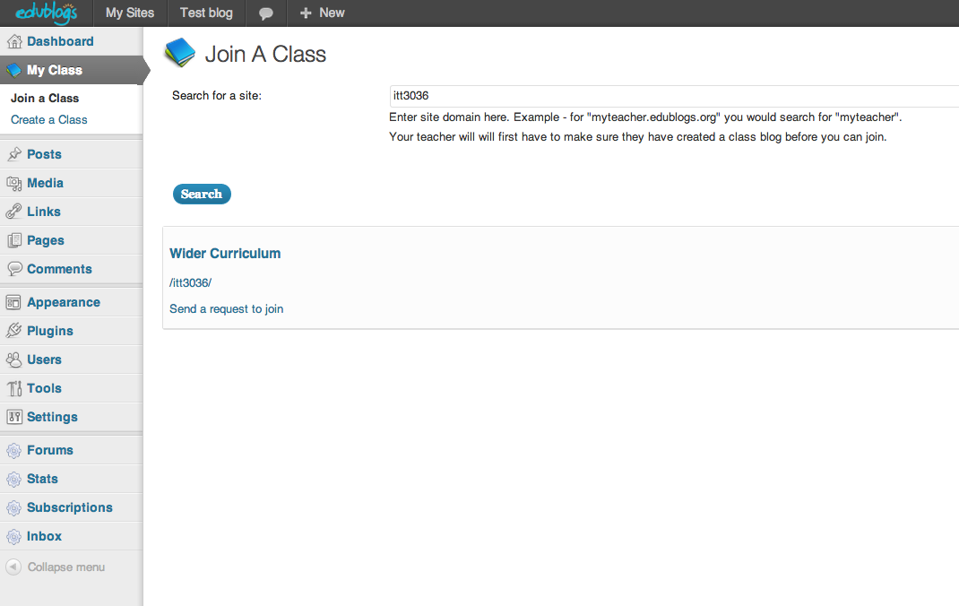

Enter the last part of the class blog URL. For example if your class blog is http://mypad.northampton.ac.uk/itt3036 you just put in itt3036.
Then click on ‘Send a request to join’.
The request will go to your tutor who will then approve you joining the class blog. This is not automatic so you may have to wait a few days. Once approved, your name will be visible on the class blog and you will be able to browse and comment on each others’ blogs. The idea is that these learning dialogues will help develop your ideas about teaching and learning.

