How to embed items in your blog

You can embed a working copy of items such as Prezi, Popplet or Scratch in your blog.
First find the embed code. It may be under an option to Share.
Copy the whole of the code, making sure you got it all.
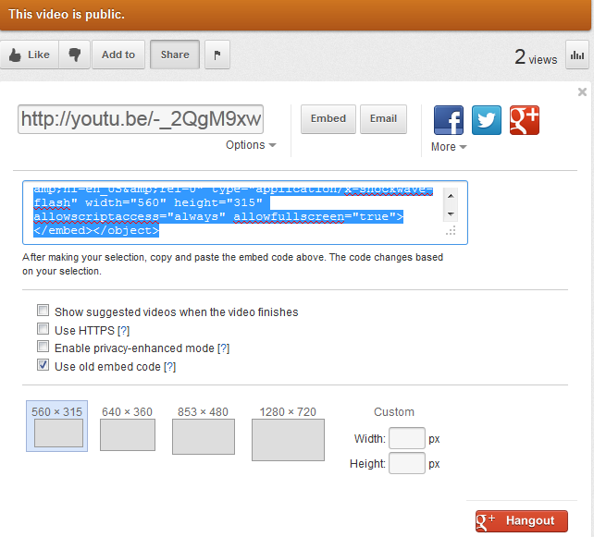
In your post click on the HTML tab and post the embed code on a new line.

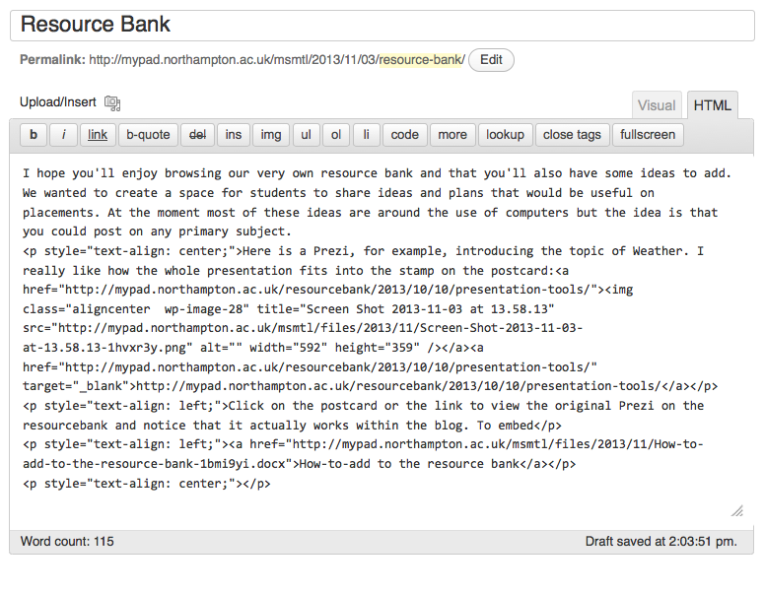
Update and publish.
You can go back to the Visual tab to add more to the post.

