How to add your Kodu game to your blog
Kodu lets kids create games on the PC and XBox via a simple visual programming language. Kodu can be used to teach creativity, problem solving, storytelling, as well as programming.
Click on Home and choose Save My world from the Home Menu
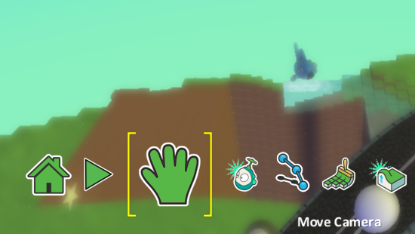
Now go to Load World
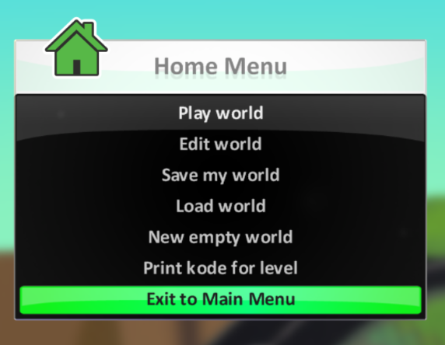
Click on your world and choose Export (to save to a stick) and also Share (to put online on the Kodu website.)
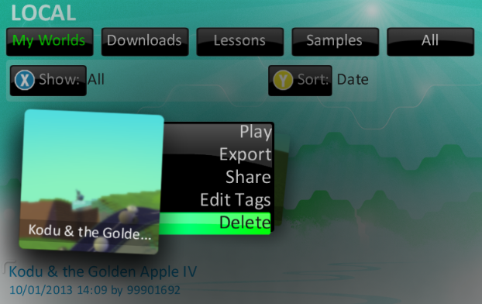
Your exported file will play on any machine with Kodu installed (including xBox).
On the website your game will have a unique URL which you can share with others and link to from your blog.
Your shared file can be downloaded from www.kodugamelab.com onto any machine with Kodu. However, you can’t just embed and play like you can with Scratch. You could get some screenshots of your game with the Snipping Tool or record a screencast of yourself playing the game with ScreenR. This is very straightforward and the screencast can be embedded.

