Video Conference (VC) is now offered within eTwinning. VC is powered by Adobe Connect.
Adobe has its own guides which can be found at
Quick Start http://www.adobe.com/content/dam/Adobe/en/products/adobeconnect/pdfs/VQS_Guide_for_Hosts.pdf
Full and Detailed (260 pages) http://help.adobe.com/en_US/connect/9.0/using/connect_9_help.pdf

The Highlights
You must pre-book a video conference slot. Start times are every 30mins on the hour and half hour. We recommend planning ahead as slots are limited – although you may be lucky enough to find an “instant” slots starting soon.
Slots are of fixed duration, but we haven’t been kicked out yet for over-running despite a warning pop-up. Be aware that this could happen though!
All times are stated in Central European Time (CET) so remember to adjust for local time zone.
VC can be launched in 3 distinct places. Guides to book a slot can be found below.
- Events – max 100 users
- Groups – max 100 users
- Twinspace –max 25 users
No matter where you launch Adobe Connect only teachers can access VC
Within TwinSpace/Groups only (Teacher) Admins can book the VC session via “create Live event”. Teachers without admin status can only join VC. They cannot see the “create live event” button
Within the TwinSpace pupils cannot see any controls to launch/join VC. The intention is that VC would be class to class facilitated through the teachers computer, rather than individual pupil to individual pupil. This class-to-class idea is represented in the reduced number of spaces available in a TwinSpace VC.
How to create a video conference - Events
Events are intended as ad-hoc training and discussion spaces, or a space to advertise face-to-face workshops. You can control access, but all events are listed on the events calendar by default. Events cannot be hidden.
VCs arranged within Events can be accessed by the Host (whomever creates the event) 24 hours in advance to allow for preparation of the space. Participants can join shortly before the allotted time

- Click on Events menu form within your eTwinning Live profile
- Click on Create An Event
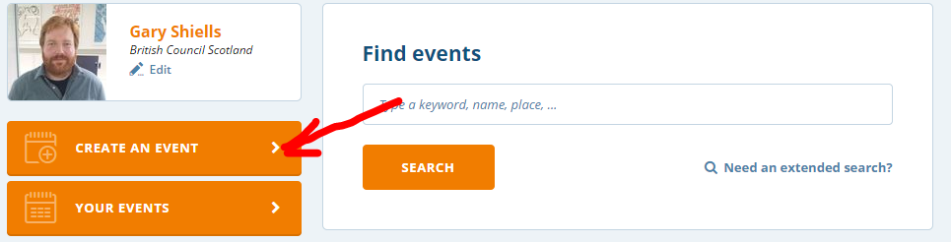
- your events Title and Description. Select Online Event. Click Next Step to progress to next screen
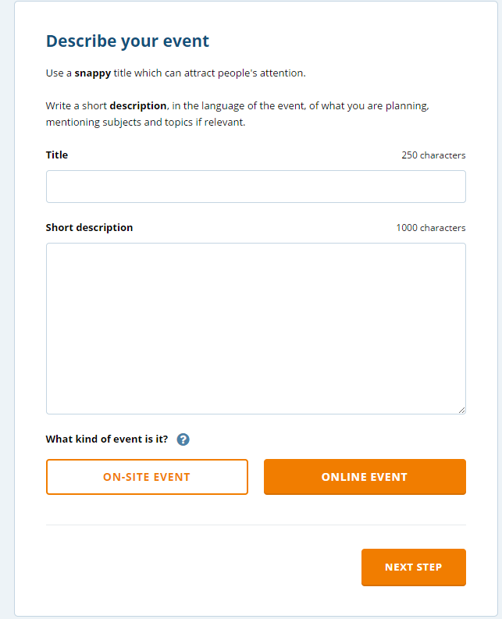

- Personalise your target audience by filling in some information about your event from the drop-downs. Add a photo for your event if you wish. Be sure to select the appropriate number of attendees.
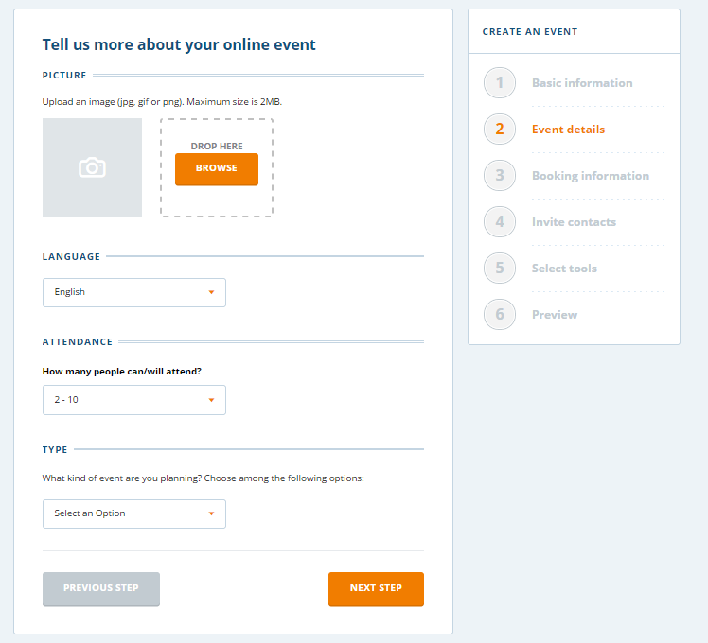
- Set access levels to your event. If you wish privacy restrict this to Only my contacts. Click within date box to activate calendar and choose your date. Once date has been selected a Search button will appear. Click Search to see available time slots 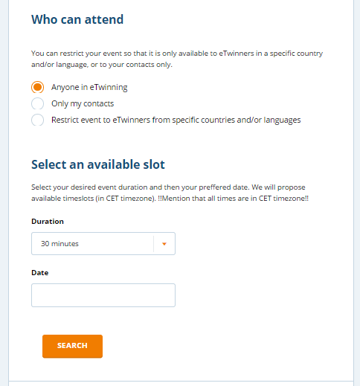
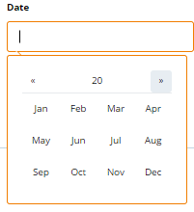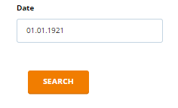
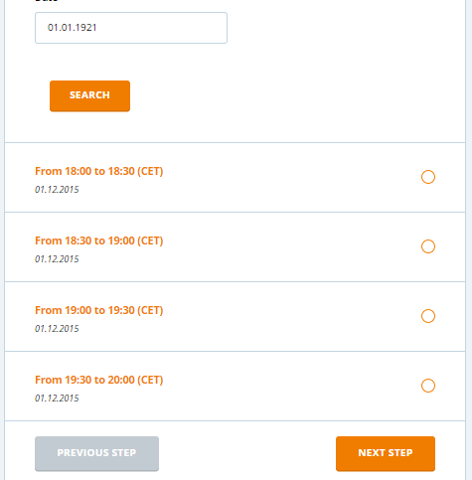

- If applicable, select which contacts to invite. You may select multiple people
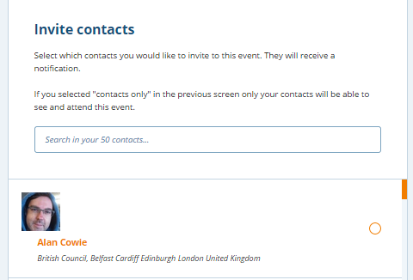
- Add in Forums and File Archive to your event if you wish. This allows the event to become a mini-collaboration site where you can upload documents before and after event, and hold preparatory / follow-up conversation in Forum
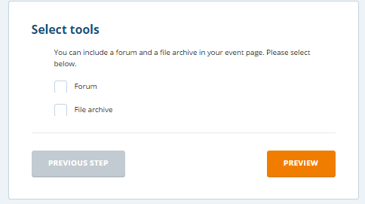
- Preview to check and content, and Submit.
- Once an event has been submitted you cannot edit the description. However Events can be deleted, or further contacts invited via My Events
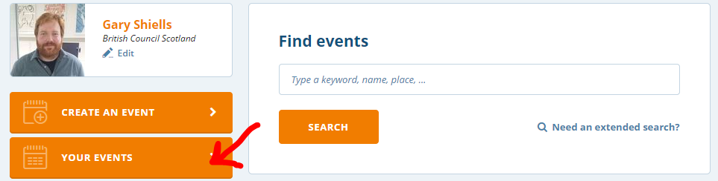
- Click on the small orange down-arrow to right of event title to expand the options to delete or invite contacts
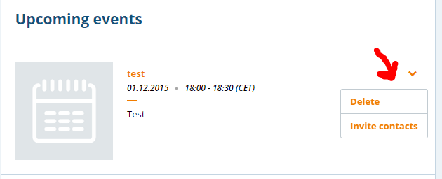

How to create a video conference - TwinSpace and Groups
Launching VC with TwinSpace or Groups will allow an element of privacy over and above Events. Only members of the Group or TwinSpace can join the session
NB TwinSpace and Groups have similar functionality and the steps are similar. Only (Teacher )Admins can arrange a VC session. Screenshots are taken from TwinSpace.
Unlike Events, Adobe Connect cannot be accessed by the host in advance.
- Click on Live menu within your TwinSpace or Group to open up chat or video sub-menu
- Click create live event to book your slot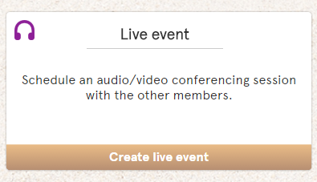
- Complete form and select suitable time slot. All time stated in CET so don’t forget to adjust backward one hour!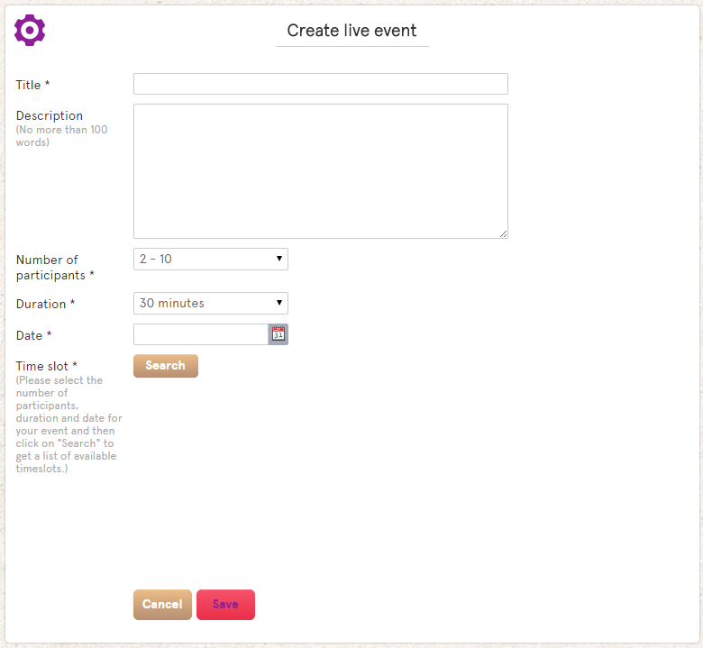
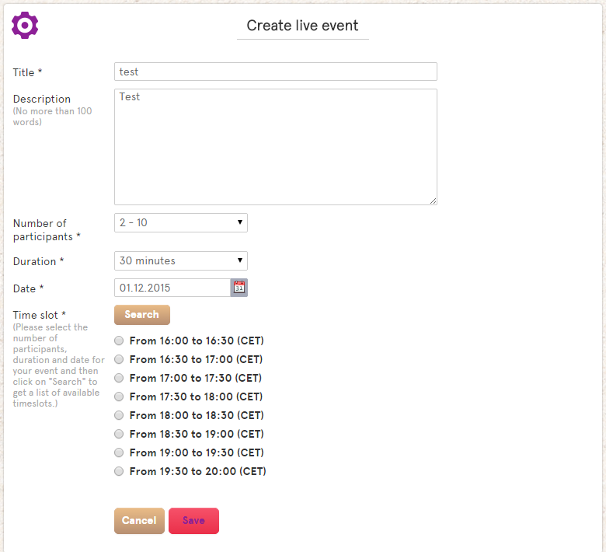

- Booked session will be visible in Live tab
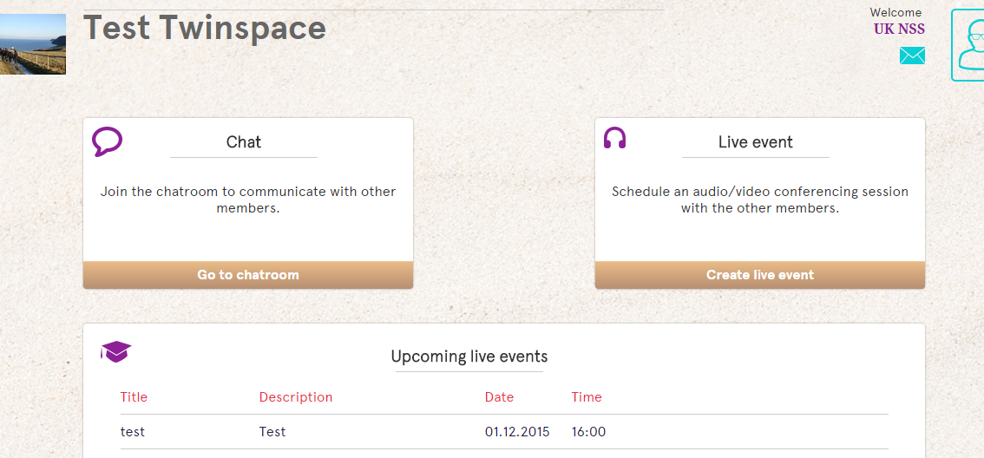

- Enter Room button will be become visible at allotted time. You may need to refresh your screen

