To add a word cloud to your blog:
First you need to add tags to your posts.
When you are posting in the Dashboard you have the option to add categories and tags:
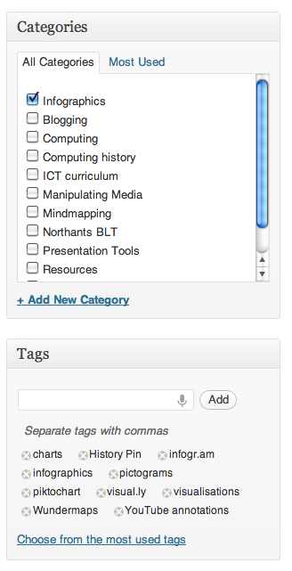
Tags are keywords to describe the content. Separate them with commas.
Once you’ve made tags for each post, go to Plugins and activate the WP-Cumulus.
Then go to Appearance and Widgets and drag the WP-Cumulus across to the Sidebar so that it is displayed on your blog.

