To add a visitor map to your blog:
1. Go to: http://clustrmaps.com/
2. Set up the ClustrMaps widget with the URL of your blog and your email.
3. They will send you an email activation link and then a password.
4. Once you activate and enter your password on the ClustrMaps site they will give you some HTML code. Copy all of this code.
5. On your blog dashboard go to Widgets and drag a Text widget onto your sidebar. Paste the code into this Text widget and Save.
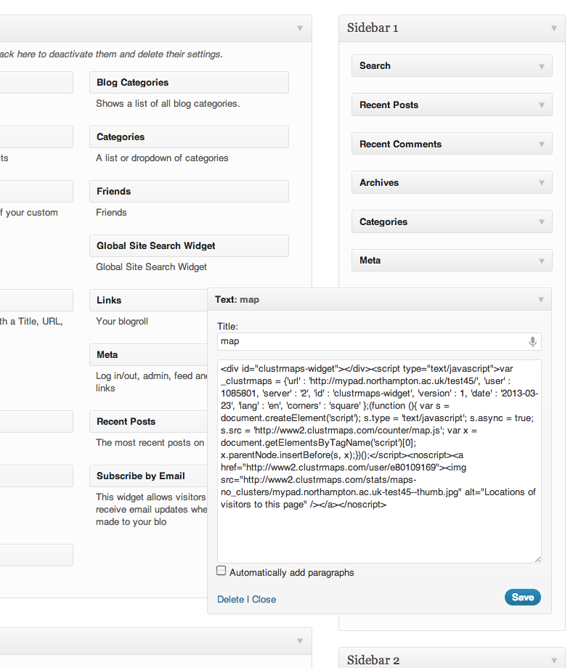
Click on the ClustrMap to see more information about your visitors. Yellow dots show live visitors.
Here are some similar widgets:
http://skysigal.xact-solutions.com/Blog/tabid/427/entryid/1919/Web-Widgets.aspx

